**LECTURER SERIES ON ANALYTICAL TECHNIQUE**

**TEJASHWINI D**

**III BSc (D section)**

**U01AG21S0728**

**R BRITTO DOMINIC RAYAN**

**Department of chemistry**

**MSCW, Mysore**

**2023-24**

**MAHARANI’S SCIENCE COLLEGE FOR WOMEN**

**Jhansi rani Lakshmi bai road, Mysore**

**Karnataka -570005**



Government of Karnataka

Department of Collegiate Education

**Maharani’s Science College for Women (Autonomous), Mysuru**

(RE-ACCREDITED BY NAAC “A” GRADE)

**Department of Chemistry**

Date:08-05-2024

**CERTIFICATE**

This is to certify that the internship entitled **“LECTURE SERIES ON HOW TO BUILD INDUSTRY AND ANALYTICAL TECHNIQUES**” was successfully carried out by **TEJASHWINI D**, a bonifide students of VI semester towards the partial fulfilment for the Bachelors of Degree (B.Sc.) during the year 2023-24. All the corrections/suggestions indicated have been incorporated in the report. The internship report has been approved as it satisfies the requirement in respect of internship work prescribed for the said degree.

Faculty Incharge Head

Department of Chemistry

**DECLARATION**

I, the under mentioned, solemnly declare that this internship report on **“LECTURE SERIES ON HOW TO BUILD THE INDUSTRY AND ANALYTICAL TECHNIQUES”** is submitted to the Department of Chemistry, Maharani’s Science College for Women (Autonomous), Mysuru in partial fulfilment of the requirements of the degree of Bachelor of Science. Further, I hereby, declare that this internship report is based on my observations, learning and experience that I gained during the internship. This internship report, neither in whole, nor in part, has been previously submitted for any degree.

Date:08-05-2024 Signature of the student

Place: Mysore …………………………

III B.Sc. ‘D’ section

MSCW, Mysuru

**CONTENTS**

|  |  |
| --- | --- |
| **SI NO** | **CONTENTS** |
| 1 | Resource persons |
| 2 | Anjali B Gupta introduction |
| 3 | How to build the industry |
| 4 | Dr. Shankara H N introduction |
| 5 | Analytical techniques |
| 6 | Dr. Mahesha V M introduction |
| 7 | Analytical techniques |
| 8 | Conclusion |

**RESOURCE PERSONS**

Lecture 1

Topic: “How to setup the industry “

**Ms. Anjali B. Gupta**

Director, Mysore Wifiltronics Pvt, Ltd., Mysuru

Lecture 2

Topic: Analytical techniques

**Dr. Shankara H. N.**

CEO, Chromatogen Analytical Solutions, Mysuru

Lecture 3

Topic: Analytical techniques

**Dr. Mahesh V. M.**

Director of Mysore Analytical Services, Mysuru

**ANJALI B GUPTA**

**Director, Mysore Wifiltronics Pvt. Ltd., Mysuru**

**Manufacturing excellence for tomorrow**

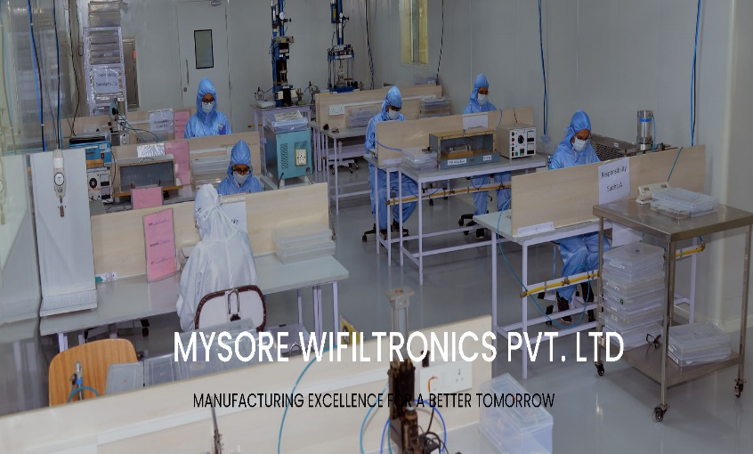Mysore wifiltronics Pvt. Ltd., located in Mysore, India, is an ISO 13485 and MDSAP certified company. Wifiltronics is CDSCO licenced company for manufacturing of medical devices. They are successful manufactures of high-quality cutting-edge technology, customer-oriented products, with emphasis on value engineering. They offer one stop shop for all contract manufacturing, designing and other manufacturing needs. A truly global company, customers are from around the global, including countries such as USA, Brazil, Australia, Germany, Italy, UK etc

Started in January 13,1992 by Dr. Alok Gupta and Mr. J. C. Gupta, one of the first developments of the company was TURP loops used in Urology. In 1994, these loops were imported into India at exorbitant prices, the cost of which was being passed down to the poorest of poorest patients. Dr. Alok Gupta along with Urologist Dr. Krishna Rao developed the “Kriloktrode” (for which they received India patent), which cut and cauterized at the same time. This way, urologists in rural areas could perform surgery without fear of devastating post operating bleeding.

The strength of our companies is in developing technical know-how and innovative approaches towards product engineering. Safety and quality are the benchmarks of manufacturing process, and in this way, they are able to offer a consistent, high level of quality. They are one of the medical device suppliers to US-FDA certified customer.

**Vision**

To manufacture excellence for a better tomorrow.

**Mission**

Mission is to engage in technically challenging projects for customers across the globe, providing innovative, indigenous and inspired solutions to meet the growing needs of a growing world, with the highest level of quality.

**Core values**

Excellence through quality and service, supportive of customers, suppliers and employees through relationship, respect and community.

**“HOW TO SETUP THE INDUSTRY”**

If you want to start own business, the first thing that is expected to do choose an industry where you would want to build a business. An entrepreneur ha many concerns: funding, staffing, developing a marketing strategy and ensuring that they have a viable product.

**1. Find out Business Opportunities**

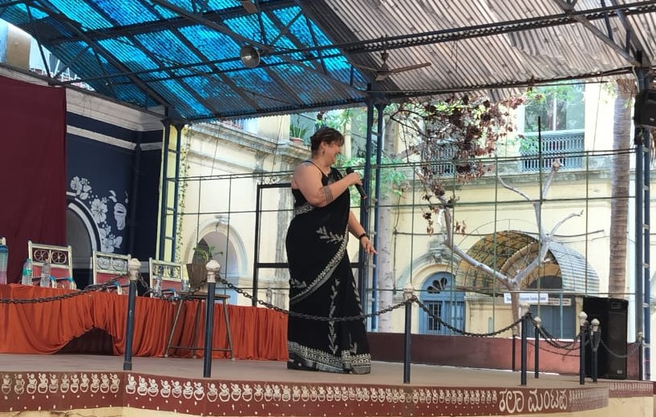Entrepreneurs should undertake the task of preparing business plan before starting a new venture. One should consult with lawyers, consultants and accountants before reaching any final decision. The nature of business is the most important decision. Businesses providing direct services like tailors, restaurants and professional services like doctors, lawyers are generally organized as proprietary concerns. While, businesses requiring pooling of skills and funds like accounting firms are better organized as partnerships.

**2. Market Survey**

Market study is one of the most essential activities that is required to understand the feasibility of the enterprise to be setup. Market study helps to get a better picture of the prevailing competition, existing gaps in the market, consumer needs and preferences etc.

**3. Selection of Business Organization**

After going through the Market survey, one needs to make the choice of the form of Business Enterprise he/she would want to setup. Making the correct choice is very crucial as it determines the power, control, risk and responsibility of the entrepreneur as well as the division of profits and losses. The various factors that need to be considered are -- Scale of operation, degree of control, amount of capital, volume of risks and liability, tax liability etc.

Some of the forms of Business organizations are: -

* Sole Proprietorship, Partnership firm,
* Co-operatives
* Private & Public Limited Company
* Societies
* Limited Liability Partnerships

**4. Name & Registration of Business**

All the business must be named and registered with the competent authorities as below: -

* Sole Proprietorship - Sole Proprietorship is a legal entity and does not require any registration for the name.
* Partnership Firm - A partnership firm can be registered with a Partnership deed where in the rights, duties and liabilities of partners are laid down. In absence of a deed, the provisions of The Indian Partnership Act, 1932 would apply.
* Co-operatives - Co-operatives need to be registered with the Registrar of Co-operatives Societies.
* Private and Public Limited Company - Registrar of companies appointed under the Companies Act, 1956 are vested with the duty of registering companies.
* Societies - It must be registered with the Registrar of Firm & Societies.
* Limited Liability Partnership -- To be registered on the website of Ministry of Corporate Affairs, developed for LLP services.

**5. Selection of Product**

The choice of a particular product or service to be manufactured by the firm can be done by analysing the following: -

* Assessing the size and structure of the market for the products.
* Determining the future demand pattern for each of them.
* Comparing their competitive positions in the market.
* Graphing the life cycle of each product.
* Finding the shelf life of each product.
* The ease of availability of raw materials.
* Technology for production.
* Manpower.
* Government policies, regulations and incentives by both state and central government.

**6. Finalizing Location**

Location of the business is the most important factor influencing its success or failure. It is a long-term decision which should take into consideration not only the present requirements of the organization but also its future expansion plans. Hence, the most advantageous location is that at which the cost of gathering material and fabricating it plus the cost of distributing the finished product to the customers will be at a minimum.

The choice of location depends on several important factors: -

* Availability of required raw materials.
* Availability of required grade of labour i.e., skilled, semi-skilled or unskilled.
* Proximity to the product market.
* Availability of transport facilities.
* Adequate supply of power and fuel.
* Climatic factors based on the product types.
* Government regulations and policies.

**7. Identifying & Understanding Target Customer**

It is very essential that there is serious thought given behind Consumer taste and preference. Supply is dependent on demand. So, it is very important to understand existing customers and find out ways to target new customers. Innovative and creative ideas need to be constantly developed to attract more and more customers. Price, design and utility of the product will have to undergo constant rectifications to align with customer’s needs. Depending on the product a certain segment of the population needs to be targeted. Trying to lure all age/income group might not work out, so it is always advisable to narrow down the target population.

**8. Infrastructure Setup**

Setting up basic infrastructural facilities for commencing business operations requires Land and Building. For acquisition of the plot of land, the entrepreneur must approach the concerned authority (Municipality, Land Revenue & Settlement Department). The architectural design of the factory must be approved by the concerned authority before starting the construction of the building. The site must be well connected to the nearest transport network i.e., rail, road or port. The availability of the basic amenities like, water, power supply is equally essential. Setting up of a good telecom facility for the industry is necessary for the growth and expansion of the business.

**9. Arranging Project Funding**

A business firm requires finance to commence its operations, to continue its operations and for its expansion and growth. Hence, a financial plan needs to be prepared, which indicates the requirements of finance, sources for raising the finance and the application of funds. Financial planning for starting a business begins with estimating the total amount of capital required by the firm for the various need of the business.

A firm may raise funds for different purposes depending on the time periods ranging from very short to fairly long duration and the business can be financed by the following means: -

* Investment of own savings
* Raising loans from friends and relatives
* Loans from Commercial Banks
* Loan from Financial Institutions
* Public deposits.

**Dr. SHANKARA H. N**

**MSc, MPhil, PhD**

**CEO, Chromatogen Analytical Solutions, Mysuru**

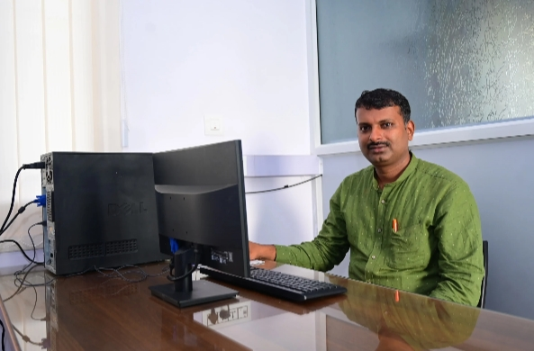Chromatogen is well equipped with the world class instruments/equipment’s which are necessary for regular analysis as per USP, IP, EP, BP, JP etc.

#### Analytical method development

#### Validation

#### Isolation of impurities from API followed by characterization

#### Purification of Chiral and Achiral compounds

#### Extraction Isolation and identification of natural products

Chromatogen is at its excellence for Method Development and Method Validation studies are complies as per ICH and regulatory guidelines.

Chromatogen is the one stop solution for the characterization of unknown and structural confirmation of known API’s, related substances, isomers, enantiomers, Diastereomers, Rotomers, positional isomers etc.,

Chromatogen provides Testing services for:

1. Pharmaceuticals
2. Raw materials and intermediated
3. Natural products/Phytochemicals
4. Adulterated foods and Pesticides
5. Dietary and Dairy products
6. Food and poultry products

**“ANALYTICAL TECHNIQUES”**

NMR is an abbreviation for Nuclear Magnetic Resonance. An NMR instrument allows the molecular structure of a material to be analysed by observing and measuring the interaction of nuclear spins when placed in a powerful magnetic field.

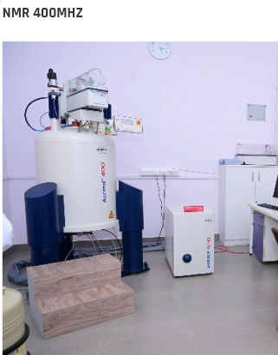

**NMR 400 MHz:**

The system is dedicated for multi nuclei (1H, 13C, 19F and 31P) solution state NMR experiments. This system also records 2D-NMR such as COSY & NOESY spectra for solving the structure of complicated molecules. It has Electromagnetic Disturbance Suppression (EDS) that provides excellent screening efficiency against external magnetic field.

**FTIR:**

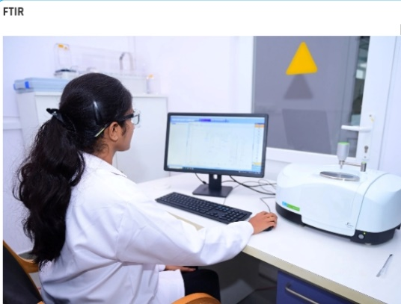"FTIR" redirects here. The term may also refer to frustrated total internal reflection.

Fourier-transform infrared spectroscopy (FTIR) is a technique used to obtain an infrared spectrum of absorption or emission of a solid, liquid, or gas. An FTIR spectrometer simultaneously collects high-resolution spectral data over a wide spectral range. This confers a significant advantage over a dispersive spectrometer, which measures intensity over a narrow range of wavelength at a time.

The term Fourier-transform infrared spectroscopy originates from the fact that a Fourier transform (a mathematical process) is required to convert the raw data into the actual spectrum.

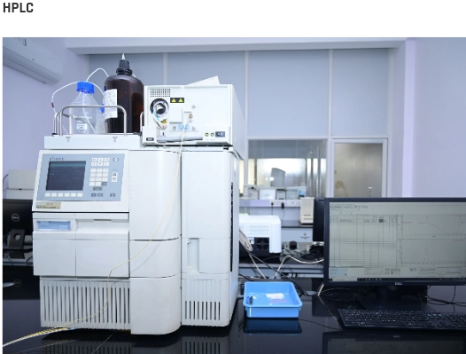

**HPLC:**

High-performance liquid chromatography (HPLC), formerly referred to as high-pressure liquid chromatography, is a technique in an analytical chemistry used to separate, identify, and quantify specific components in mixtures. The mixtures can originate food, chemicals, pharmaceuticals, biological and agriculture.

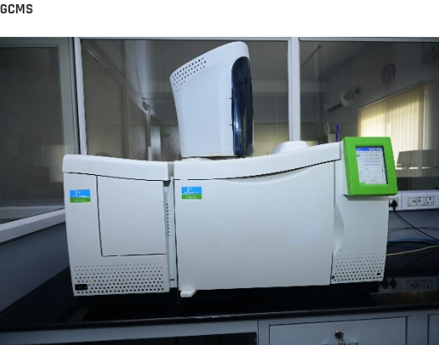**GCMS:**

Gas chromatography–mass spectrometry (GC–MS) is an analytical method that combines the features of gas chromatography and mass chromatography to identify different substances within a test sample. Applications of GC–MS include drug detection, fire investigation, environmental analysis, explosive investigation, food and flavour analysis, and identification of unknown samples, including that of material samples obtained from planet Mars during probe missions, GC–MS can also be used in airport security to detect substances in luggage or on human beings. Additionally, it can identify trace element in materials that were previously thought to have disintegrated beyond identification.

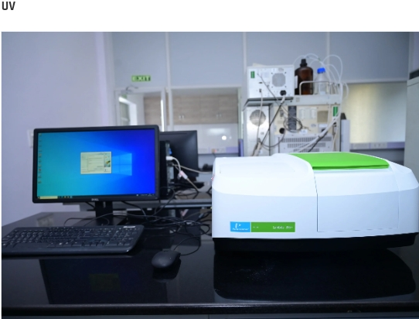**UV:**

Ultraviolet (UV) spectroscopy or ultraviolet–visible (UV–VIS) spectrophotometry refers to [absorption spectroscopy](https://en.wikipedia.org/wiki/Absorption_spectroscopy) or reflectance spectroscopy in part of the [ultraviolet](https://en.wikipedia.org/wiki/Ultraviolet) and the full, adjacent [visible](https://en.wikipedia.org/wiki/Visible_spectrum) regions of the [electromagnetic spectrum](https://en.wikipedia.org/wiki/Electromagnetic_spectrum).[[2]](https://en.wikipedia.org/wiki/Ultraviolet%E2%80%93visible_spectroscopy#cite_note-:1-2) Being relatively inexpensive and easily implemented, this methodology is widely used in diverse applied and fundamental applications. The only requirement is that the sample absorb in the UV-Vis region, i.e. be a [chromophore](https://en.wikipedia.org/wiki/Chromophore). Absorption spectroscopy is complementary to [fluorescence spectroscopy](https://en.wikipedia.org/wiki/Fluorescence_spectroscopy)

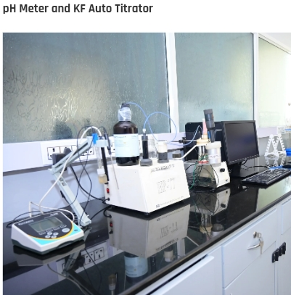**PH METER AND KF AUTO TITRATOR:**

pH meter is a [scientific instrument](https://en.wikipedia.org/wiki/Scientific_instrument) that measures the [hydrogen-ion](https://en.wikipedia.org/wiki/Hydrogen-ion) [activity](https://en.wikipedia.org/wiki/Thermodynamic_activity) in [water-based solutions](https://en.wikipedia.org/wiki/Aqueous_solution), indicating its [acidity](https://en.wikipedia.org/wiki/Acidity) or [alkalinity](https://en.wikipedia.org/wiki/Alkalinity) expressed as [pH](https://en.wikipedia.org/wiki/PH). The pH meter measures the difference in [electrical potential](https://en.wikipedia.org/wiki/Electrical_potential) between a pH electrode and a reference electrode, and so the pH meter is sometimes referred to as a "potentiometric pH meter".

 Karl Fischer titration is a classic [titration](https://en.wikipedia.org/wiki/Titration) method that uses [coulometric](https://en.wikipedia.org/wiki/Coulometry) or [volumetric](https://en.wikipedia.org/wiki/Volume) titration to determine trace amounts of [water](https://en.wikipedia.org/wiki/Water) in a sample. It was invented in 1935 by the German chemist [Karl Fischer](https://en.wikipedia.org/wiki/Karl_Fischer_(chemist)).[[1]](https://en.wikipedia.org/wiki/Karl_Fischer_titration#cite_note-1)[[2]](https://en.wikipedia.org/wiki/Karl_Fischer_titration#cite_note-2) Today, the titration is done with an automated Karl Fischer titrator.

**Dr. MAHESHA V M**

**MSc Biochemistry**

**Director, Mysore Analytical Services, Mysuru**

y

We are providing hands on Quality control training, HPLC and GC hands on training, Internship for Postgraduate and graduate students, Analytical projects, Consultancy etc

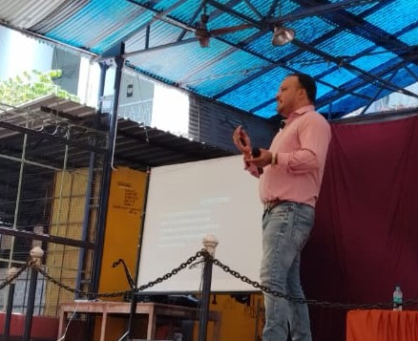We focus on High-Performance Liquid Chromatography (HPLC), Gas Chromatography (GC) and a wide array of other analytical instruments, we are your trusted partner for comprehensive training solution. Our Commitment Knowledge and Expertise With a team of highly skilled instructors and industry experts, we bring a wealth of knowledge and practical experience to each training session. Our commitment to excellence ensures that you receive the most up-to-date information and hands-on training in the field Customized Training We understand that every organization has unique requirements. That's why we offer tailored training programs to suit your specific needs. Whether you are looking to enhance your team's skills or provide individualized training, we can accommodate your goals Cutting-Edge Facilities: Our state-of-the-art training facilities are equipped with the latest analytical instruments.

### HPLC - hands on training

### Gc - hands on training

### Qc - hands on training

### Quality assurance training

We provide a conducive learning environment where participants can gain valuable hands-on experience. Wide Range of Industries Our training programs cater to professionals across a spectrum of industries, including pharmaceuticals, food and beverage, medical research, and more. We ensure that our courses are relevant to your sector.

Top of Form

Bottom of Form

**“ANALYTICAL TECHNIQUES”**

Chromatography is a separation technique which is used to separate the mixture of compounds into its individual components based on certain physical and chemical properties.

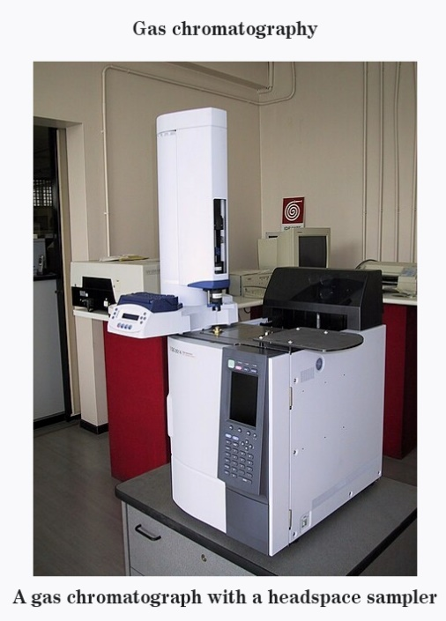**Gas Chromatography (GC):**

Gas chromatography differs from other forms of [**chromatography**](https://microbenotes.com/chromatography-principle-types-and-applications/) in that the mobile phase is a gas and the components are separated as vapours.

It is thus used to separate and detect small molecular weight compounds in the gas phase.

The sample is either a gas or a liquid that is vaporized in the injection port. The mobile phase for gas chromatography is a carrier gas, typically helium because of its low molecular weight and being chemically inert.

The pressure is applied and the mobile phase moves the analyte through the column. The separation is accomplished using a column coated with a stationary phase

**Principle:**

It is a separation technique by using solid or liquid stationary phase and gas as a mobile phase

Sample components are separated on the basis of partition chromatography

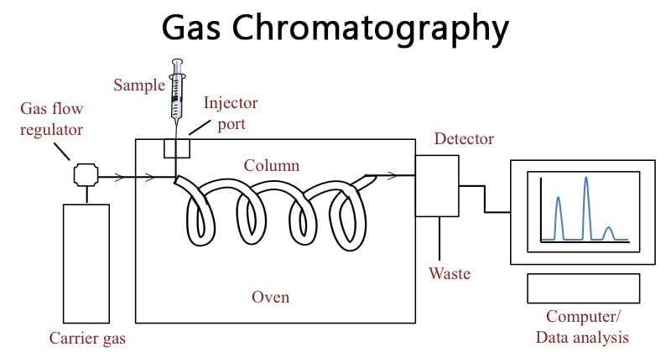**Components of gas chromatography:**

1. Sample injector:

vaporization technique-split, spitless, direct

Cold injector technique-OCI/PIV

1. Column:

Packed column and capillary column

1. Oven
2. Detector:

Fame ionisation detector (FID)

Thermal conductivity detector (TCD)

Electron capture detector (ECD)

Flame photometric detector (FPD)

1. Data system

**Procedure of gas chromatography:**

Top of Form

**Step 1: Sample Injection and Vaporization**

* A small amount of liquid sample to be analysed is drawn up into a syringe.
* The syringe needle is positioned in the hot injection port of the gas chromatograph and the sample is injected quickly.
* The injection of the sample is considered to be a “point” in time, that is, it is assumed that the entire sample enters the gas chromatograph at the same time, so the sample must be injected quickly.
* The temperature is set to be higher than the boiling points of the components of the mixture so that the components will vaporize.
* The vaporized components then mix with the inert gas mobile phase to be carried to the gas chromatography column to be separated.

**Step 2: Separation in the Column**

* Components in the mixture are separated based on their abilities to adsorb on or bind to, the stationary phase.
* A component that adsorbs most strongly to the stationary phase will spend the most time in the column (will be retained in the column for the longest time) and will, therefore, have the longest retention time (Rt). It will emerge from the gas chromatograph last.
* A component that adsorbs the least strongly to the stationary phase will spend the least time in the column (will be retained in the column for the shortest time) and will, therefore, have the shortest retention time (Rt).  It will emerge from the gas chromatograph first.
* If we consider a component mixture in which component A is more polar than component B then:

1.component A will have a**longer retention time** in a polar column than component B

2.component A will have a **shorter retention time** in a non-polar column than component B

**Step 3: Detecting and Recording Results**

* The components of the mixture reach the detector at different times due to differences in the time they are retained in the column.
* The component that is retained the shortest time in the column is detected first. The component that is retained the longest time in the column is detected last.

The detector sends a signal to the chart recorder which results in a peak on the chart paper. The component that is detected first is recorded first.  The component that is detected last is recorded last.

**Application:**

* GC analysis is used to calculate the content of a chemical product, for example in assuring the quality of products in the chemical industry; or measuring toxic substances in soil, air or water.
* Gas chromatography is used in the analysis of air borne pollutants, performance-enhancing drug in athlete’s urine samples, oil spills, essential oils in perfume preparation.
* GC is very accurate if used properly and can measure picomole’s of a substance in 1ml liquid sample, or ppm concentrations in gaseous samples.

**HPLC chromatography: 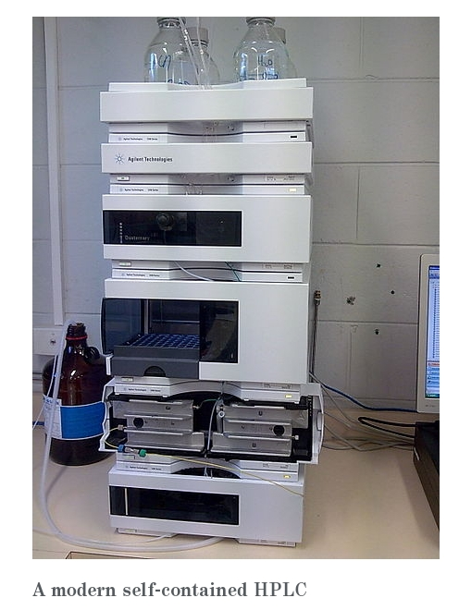High-performance liquid chromatography or commonly known as HPLC, is an analytical technique used to separate, identify or quantify each component in a mixture.**

The mixture is separated using the basic principle of column [**chromatography**](https://microbenotes.com/chromatography-principle-types-and-applications/) and then identified and quantified by spectroscopy.

In the 1960s, the column chromatography LC with its low-pressure suitable glass columns was further developed to the HPLC with its high-pressure adapted metal columns.

HPLC is thus basically a highly improved form of column liquid chromatography. Instead of a solvent being allowed to drip through a column under gravity, it is forced through under high pressures of up to 400 atmospheres.

**Principle:**

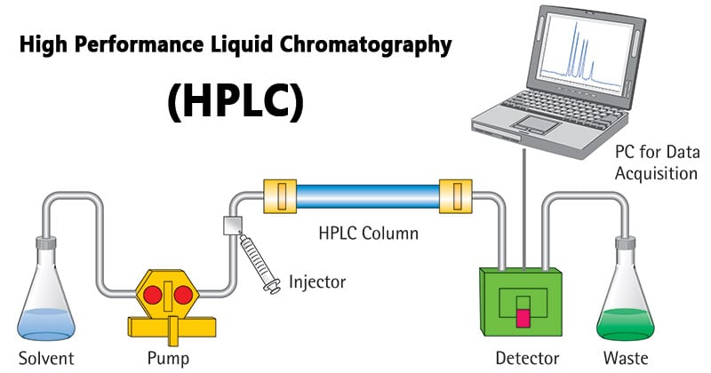The purification takes place in a separation column between a stationary and a mobile phase.

The stationary phase is a granular material with very small porous particles in a separation column.

The mobile phase, on the other hand, is a solvent or solvent mixture which is forced at high pressure through the separation column.

**Instrumentation of HPLC:**

**The Pump**

* The development of HPLC led to the development of the pump system.
* The pump is positioned in the most upper stream of the liquid chromatography system and generates a flow of eluent from the solvent reservoir into the system.
* High-pressure generation is a “standard” requirement of pumps besides which, it should also to be able to provide a consistent pressure at any condition and a controllable and reproducible flow rate.
* Most pumps used in current LC systems generate the flow by back-and-forth motion of a motor-driven piston (reciprocating pumps). Because of this piston motion, it produces “pulses”.

**Injector**

* An injector is placed next to the pump.
* The simplest method is to use a syringe, and the sample is introduced to the flow of eluent.
* The most widely used injection method is based on sampling loops.
* The use of the autosampler (auto-injector) system is also widely used that allows repeated injections in a set scheduled-timing.

**Column**

* The separation is performed inside the column.
* The recent columns are often prepared in a stainless-steel housing, instead of glass columns.
* The packing material generally used is silica or polymer gels compared to calcium carbonate.  
  The eluent used for LC varies from acidic to basic solvents.
* Most column housing is made of stainless steel since stainless is tolerant towards a large variety of solvents.

**Detector**

* Separation of analytes is performed inside the column, whereas a detector is used to observe the obtained separation.
* The composition of the eluent is consistent when no analyte is present. While the presence of analyte changes the composition of the eluent. What detector does is to measure these differences.
* This difference is monitored as a form of an electronic signal. There are different types of detectors available.

**Recorder**

* The change in eluent detected by a detector is in the form of an electronic signal, and thus it is still not visible to our eyes.
* In older days, the pen (paper)-chart recorder was popularly used. Nowadays, a computer-based data processor (integrator) is more common.
* There are various types of data processors; from a simple system consisting of the in-built printer and word processor while those with software that are specifically designed for an LC system which not only data acquisition but features like peak-fitting, baseline correction, automatic concentration calculation, molecular weight determination, etc.

**Degasser**

The eluent used for LC analysis may contain gases such as oxygen that are non-visible to our eyes.

* When gas is present in the eluent, this is detected as noise and causes an unstable baseline.
* Degasser uses special polymer membrane tubing to remove gases.
* The numerous very small pores on the surface of the polymer tube allow the air to go through while preventing any liquid to go through the pore.

**Column Heater**

The LC separation is often largely influenced by the column temperature.

* In order to obtain repeatable results, it is important to keep consistent temperature conditions.
* Also, for some analysis, such as sugar and organic acid, better resolutions can be obtained at elevated temperatures (50 to 80°C).
* Thus, columns are generally kept inside the column oven (column heater).

**Types of HPLC:**

1. **Normal phase:**

Column packing is polar (e.g., silica) and the mobile phase is non-polar. It is used for water-sensitive compounds, geometric isomers, cis-trans isomers, and chiral compounds.

1. **Reverse phase:**

The column packing is non-polar (e.g., C18), the mobile phase is water miscible solvent (e.g., methanol). It can be used for polar, non-polar, ionizable, and ionic samples.

1. **Ion exchange:**

Column packing contains ionic groups and the mobile phase is buffer. It is used to separate anions and cations.

1. **Size exclusion:**

Molecules diffuse into pores of a porous medium and are separated according to their relative size to the pore size. Large molecules elute first and smaller molecules elute later.

**Applications:**

The HPLC has developed into a universally applicable method so that it finds its use in almost all areas of chemistry, biochemistry, and pharmacy.

* Analysis of drugs, synthetic polymers and pollutants in environmental analytics.
* Determination of drugs in biological matrices and isolation of valuable parts.
* Product purity and quality control of industrial products and fine chemicals
* Separation and purification of biopolymers such as enzymes or nucleic acids
* Water purification, Pre-concentration of trace components and Ligand-exchange chromatography and Ion-exchange chromatography of proteins
* High-pH anion-exchange chromatography of carbohydrates and oligosaccharides

**CONCLUSION**

On the whole, as the part of internship the lecture series was a useful experience. We have gained new knowledge, skills and met new resource persons. We achieved several of our learning goals. Related to the study we learn more about analytical instruments. Its really give good knowledge for us.

Furthermore, we have experienced that it is of important that education is objective and that we have to be aware of the aspect of the topics we study Analytical technique.

This internship programme was not one sided, but it was a way of sharing knowledge ideas and opinions. This helped us to define what skills and knowledge we have to improve in the coming time. We can confidently assert that the knowledge we gained through this internship is definitely useful for us. At last internship has given us new insights and motivation to pursue my career in the chemistry field.